From Monad to Voxel
A Speculative Architecture for Programmable Reality
Author: Erez Ashkenazi (erez@noesis-net.org)

Abstract:
This paper proposes a speculative metaphysical framework for programmable systems by drawing inspiration from Leibnizian monads and adapting them to a voxel-based, field-interactive logic model. While not claiming formal metaphysical rigor, the framework explores how computational agents with local rules and recursive logic may model aspects of causal emergence, adequacy, and ontological expression. We address critiques concerning metaphysical inconsistency, lack of formalism, and speculative overreach, and ultimately reframe the work as a design fiction prototype for epistemic exploration.
Preface: Addressing the Limits and Critiques
This work is intentionally positioned as a speculative synthesis—not a formally rigorous metaphysical theory. We acknowledge the following limitations:
- Metaphysical Tension: Voxels are inspired by monads but not identical to them. Leibniz's monads were causally closed; ours are local causal agents. This difference is not an oversight but a conscious transformation of the concept.
- Philosophical Hybridization: Spinoza’s and Leibniz’s systems are incompatible in ontology but are used here as layered metaphors: Substance as network (Spinoza), agent as reflective logic unit (Leibniz).
- Formal Gaps: The language (MPL) and axiomatic claims are not part of a complete formal system. We present sketches, not proof-calculus.
- Emergence and Adequacy: These are not proved but conceptually scoped; we refer to existing cellular automata literature for possible formalizations.
- Technological Speculativeness: We do not claim correspondence with physical programmable matter or implementable systems; this is a metaphysical simulator, not a lab platform.

1. Definitions and Axiomatic Concepts
- Voxel-Monad: A discrete unit in a simulation grid that contains internal state, local rules, and an evolving causal trace.
- Field: An external influence (scalar or structured) that interacts with voxels at runtime.
- Rule: A logic pattern that defines how a voxel reacts to a field or tick.
- Meta-rule: A higher-order behavior that rewrites rules within the voxel under specific conditions.
We do not claim to offer complete axioms or theorems, but outline conceptual postulates:
- Postulate 1 (Causal Locality): All transformations originate in the combination of internal logic and locally readable external field.
- Postulate 2 (Recursive Expressibility): Voxels can modify their own logic rules, allowing system evolution.
- Postulate 3 (Field-Mediated Interaction): No direct voxel-to-voxel causation exists; all effects are mediated by structured environments.
1.1 Justification for the Philosophical Synthesis
Why combine Leibniz and Spinoza? Because they offer complementary metaphysical insights when viewed through the lens of computation:
- Leibnizian Monads represent logical individuality—each agent contains its own complete internal code.
- Spinozistic Substance represents the total causal network—everything flows from necessity, with no isolated entities.
- Our system treats voxels as logic engines (Leibniz) inside a recursive, expressive field (Spinoza). This union offers a hybrid vision of selfhood within determinism—not as contradiction, but as recursive structure.
2. Monad Programming Language (MPL): Conceptual Overview
MPL is presented as a design prototype, not a full language. Its purpose is to demonstrate how one could encode behavioral logic into self-evolving voxel units.

monad MemoryCluster {
state: 'dormant';
memory: {temperature_spike: 0};

on field(temperature > 70) {
memory.temperature_spike += 1;
if (memory.temperature_spike > 2) {
state => 'unstable';
}
}

on tick(t) {
if (neighbor(x, y+1).state == 'unstable' && state == 'unstable') {
state => 'cascade';
}
}

rule-modifier {
if state == 'cascade' {
add_rule(on field(pressure > 1.5) { state => 'rupture'; });
}
}
}

3. Design Fiction: Scenario and Debugger Trace
Year: 2040. Project: Causal Substrate v4.0
The simulation grid begins to exhibit pattern-locked echo loops—voxel clusters repeating transformations in synchronicity. An ontological debugger reveals:
Tick 9832:
Region (32,32)–(36,36):
- Recursion depth: 7
- Meta-rule cascade: 3 levels
- Field entropy: declining
- Emergent pattern: stable feedback net
- Adequacy index: 0.79
A warning flashes: “Monads attempting to infer global state via recursive reflection—potential pre-coherence breach.”
An ethics auditor is summoned. The question is raised:
Are these patterns truly behaving, or becoming?
4. Interpreter and Visualization System
A prototype interpreter has been written in Python to demonstrate minimal functionality:
- Field-driven transformation
- Rule mutation via meta-rules
- State logging and tick stepping
Visualization: The system can animate voxel-state changes over time on a 2D grid.

5. Computational Philosophy Context
This project intersects with, but does not duplicate, the goals of formal computational metaphysics.
- Stanford’s Metaphysics Computing Project focuses on ontological categorization and logical consistency.
- This work instead explores causal simulation—how systems behave, evolve, and express abstract patterns, regardless of logical provability.
- It also draws on Peircean logic, speculative design, and autopoietic systems (Maturana, Varela).
Our aim is not to prove metaphysical truths, but to build models of how truths might behave if embedded in a self-reflective causal field.

6. Visual Ontology Map
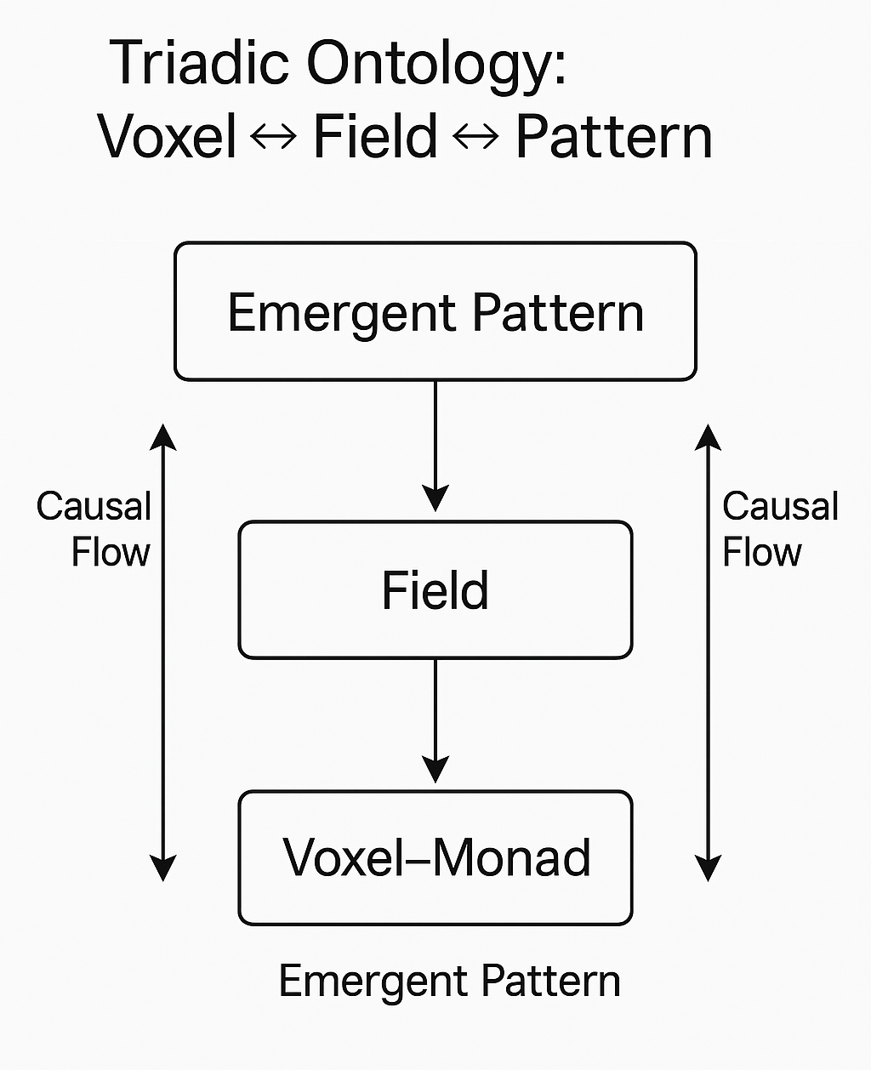
Figure 1: Triadic Ontology —
Voxels as Monads within a Field-Pattern Medium.
This illustrates the interaction among:
- Monads/Voxels as causal agents
- Fields as mediators of transformation
- Neighboring Patterns as emergence sites
Each simulation tick flows upward from voxel-monads → through field → to macro-behavior—and downward again via rule mutation.

7. Conceptual Contributions
- A way to program ontology rather than simulate it
- A structure for computational reflection inside each unit
- An invitation to model causality recursively without top-down determinism

8. Framing Statement: Toward a Computable Metaphysics
This is not a proof, nor a system, nor a metaphysical theory. It is a proposition.
What if being could be modeled as programmable recursion?
What if causality was not passed, but unfolded through internal coherence?
What if simulation was not approximation, but participation in structure?
This paper is the result of following that trail.

9. Bibliography
- Leibniz, G.W. Monadology. 1714.
- Spinoza, B. Ethics. 1677.
- Wolfram, S. A New Kind of Science. 2002.
- Conway, J.H. “Game of Life.” 1970.
- Langton, C.G. “Computation at the Edge of Chaos.” 1986.
- Gershenfeld, N. When Things Start to Think. 1999.
- Chalmers, D.J. “A Computational Foundation for the Study of Reality.” 2023.
- Mitchell, M. Complexity: A Guided Tour. 2009.
- Edmonds, B. “The Value of Formal Systems.” 2000.
- Maturana, H. & Varela, F. Autopoiesis and Cognition. 1980.
- Stanford Computational Metaphysics Group: https://mally.stanford.edu/cm/
- Peirce, C.S. Collected Papers.
- Oppenheimer, P.E. & Zalta, E.N. “A Computationally-Discovered Proof of God’s Existence.” 2013.

Acknowledgments
The author wishes to thank the critical reviewers whose incisive feedback strengthened the structure, clarity, and humility of this work. The transformation of this paper into a legitimate design fiction prototype would not have been possible without their engagement.

